
Koneru Lakshmaiah Education Foundation
(Deemed to be University estd. u/s. 3 of the UGC Act, 1956)
Off-Campus: Bachupally-Gandimaisamma Road, Bowrampet, Hyderabad, Telangana - 500 043. Phone No: 7815926816, www.klh.edu.in

STUDENT CASE STUDY EXECUTION REPORT
Department | FED
Subject | DSA-2
Academic Year | 1-111 Semester | 2025-26
Faculty Name | Mohd. Razia Alangir Banu
Student Name | M. Shravya
Roll Number | 2520030588
Branch | CSE
Course Outcome | CO 2
Case Study Topic: Certification Verification System using B+ Tree
Work Done Summary:
In this case study, we implemented a B+ Tree data structure for efficient storage and verification of certificate records in the Skill Bridge – Online Skill Development & Certification Platform. The B+ Tree organizes certificates based on Certificate ID and supports fast search operations and range queries for certificates issued within a specified date range.

Implementation Details:

1 Implemented B+ Tree insertion and search operations.
2 Stored certificate records using Certificate ID as the indexing key.
3 Maintained linked leaf nodes for efficient sequential access.
4 Performed node splitting during overflow conditions.
5 Enabled certificate verification using Certificate ID.
6 Implemented range query operations to retrieve certificates issued between two dates
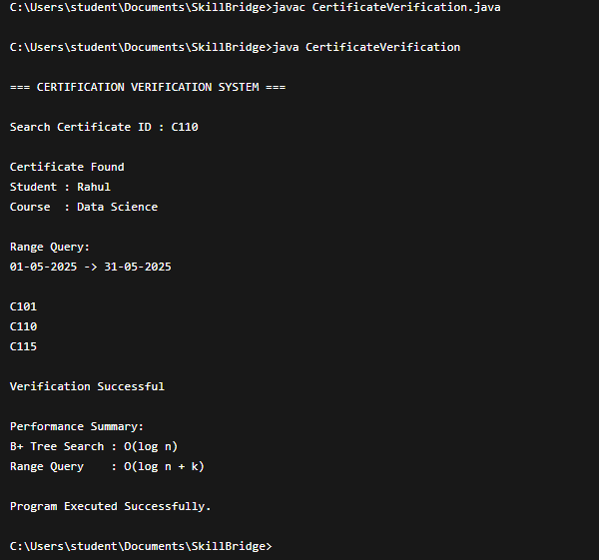

Result: Screenshots / Output

Time Complexity:
Operation | Complexity
B+ Tree Search | O(log n)
B+ Tree Insertion | O(log n)
Certificate Verification | O(log n)
Range Query | O(log n + k)

Result
The B+ Tree efficiently indexed certificate records and enabled rapid certificate verification. The linked leaf-node structure allowed fast range queries for certificates issued within specific date ranges, making it highly suitable for large-scale certification management systems.

GitHub Link:
Student Signature Faculty Signature

